- zero-shot and few-shot prompting
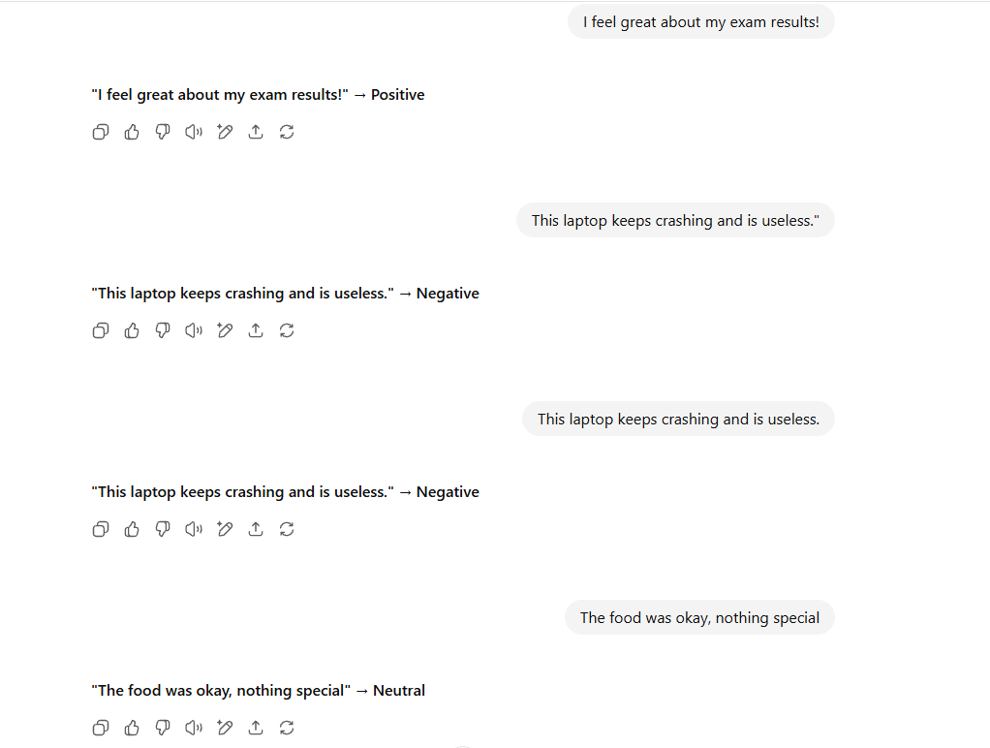
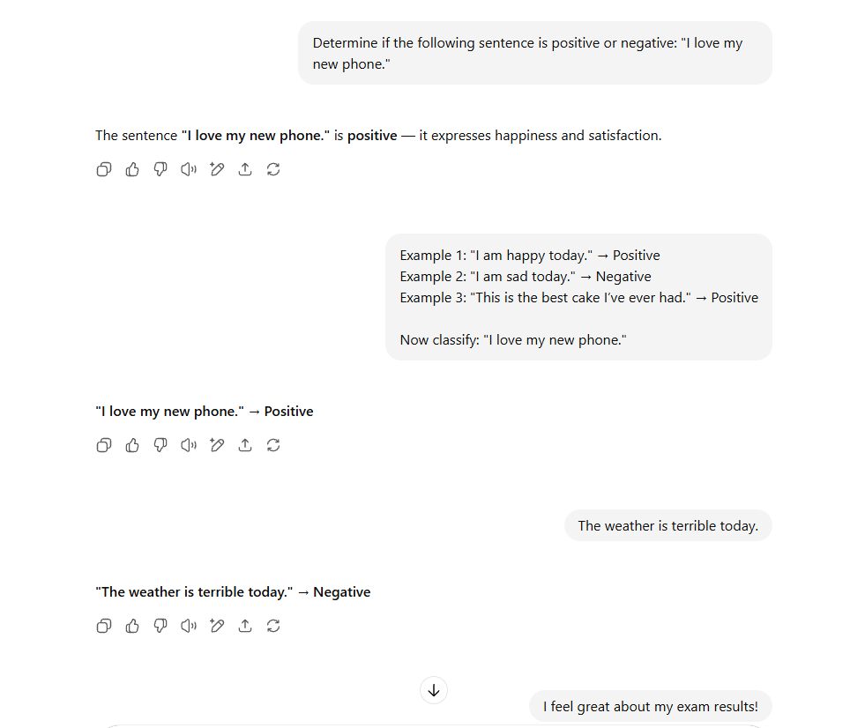

Test Sentence | Zero-shot Output | Few-shot Output | Actual Sentiment
"The weather is terrible today." | Negative | Negative | Negative
"I feel great about my exam results!" | Positive | Positive | Positive
"This laptop keeps crashing and is useless." | Negative | Negative | Negative
"The food was okay, nothing special." | Positive | Neutral/Negative | Neutral/Negative
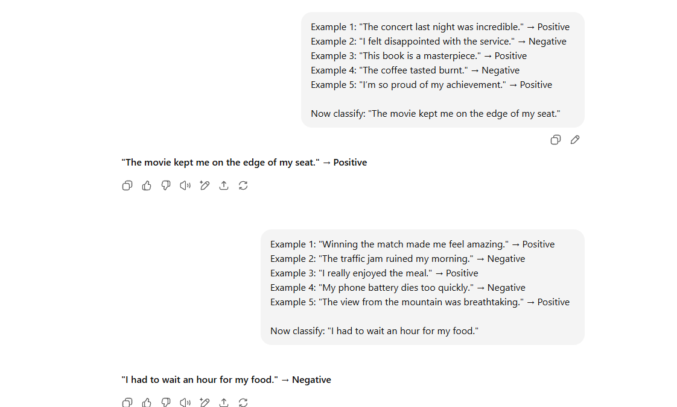
Observations:
Zero-shot Prompting
- The model tries to guess the task from the single instruction.

Few-shot Prompting
- Providing examples sets the tone and clarifies expected output format.

